1. During first login after installing Jenkins, the screen looks like

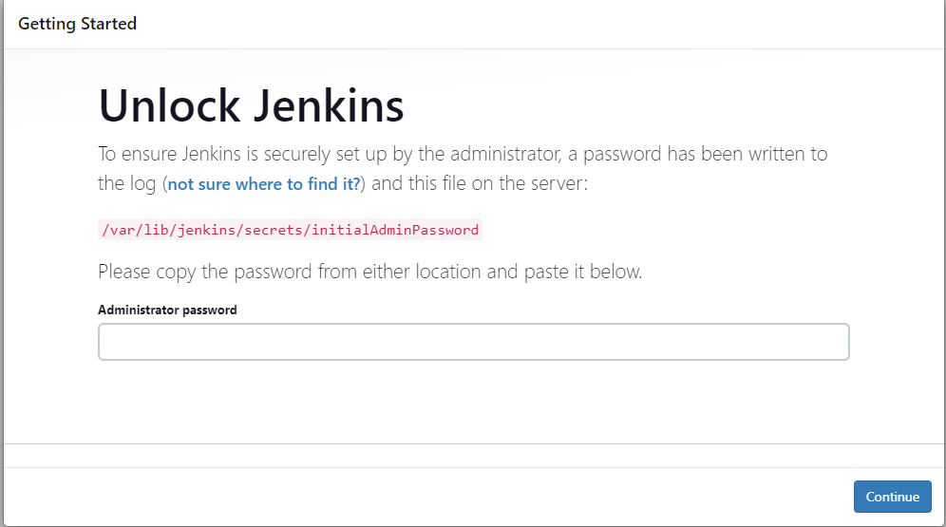

1. Login to the server and get the password from the given path by the command

sudo cat /var/lib/jenkins/secrets/initialAdminPassword

1. Create user id and password.

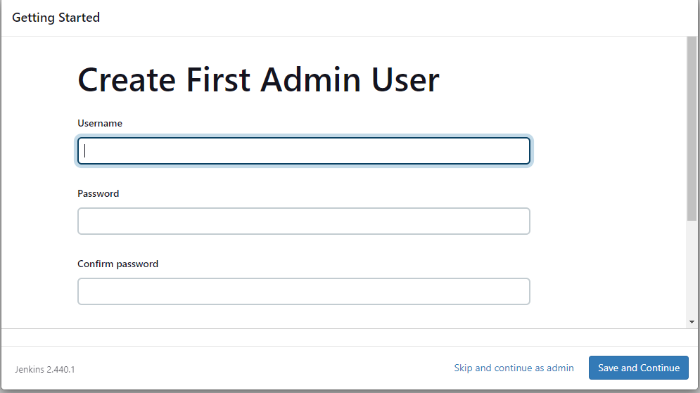

1. Go to manage Jenkins -> plugins and install the below mentioned plugins
2. SonarQube Scanner
3. Sonar Quality Gates
4. Quality Gates
5. OWASP Dependency-check
6. Official OWASP ZAP
7. Docker
8. Docker common
9. Docker Pipeline
10. Docker API
11. Docker build steps
12. Kubernetes
13. Kubernetes Client API
14. Kubernetes Credentials
15. Kubernetes cli
16. Go to manage Jenkins -> credentials and click on global to add a credentials
17. For sonarqube, kind will be secret text, enter a name in the ID field to identify, enter the token copied from sonarqube and provide a description
18. Click on create.
19. Add credentials for docker hub abd github
20. Goto manage Jenkins -> System -> Sonarqube Servers

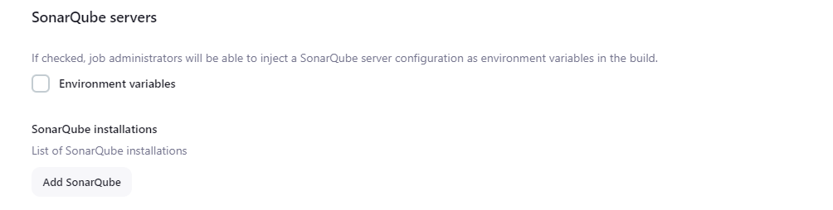

1. Click on Add SonarQube
2. Enter name and IP

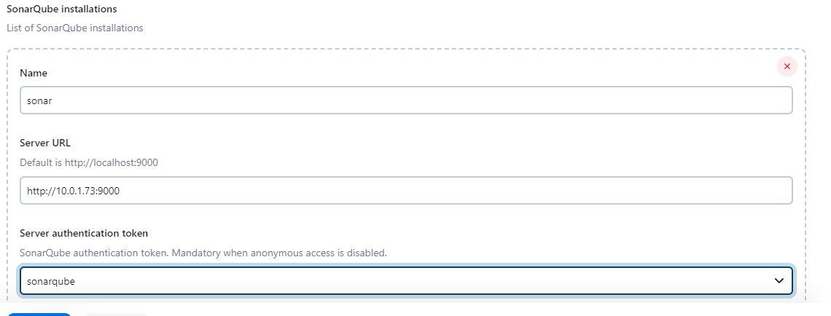

1. Choose token from the dropdown and click on Save.
2. Goto manage Jenkins -> tools -> JDK installations
3. Enter the details

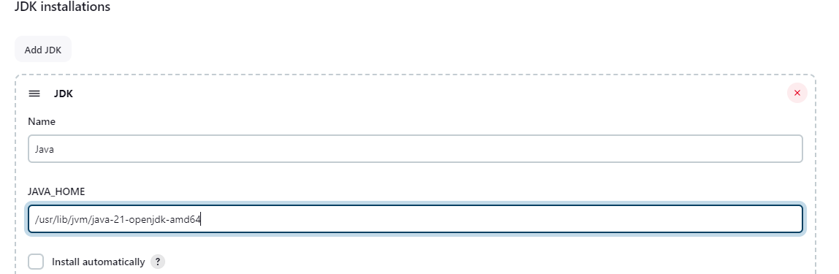

1. Configure SonarQube Scanner

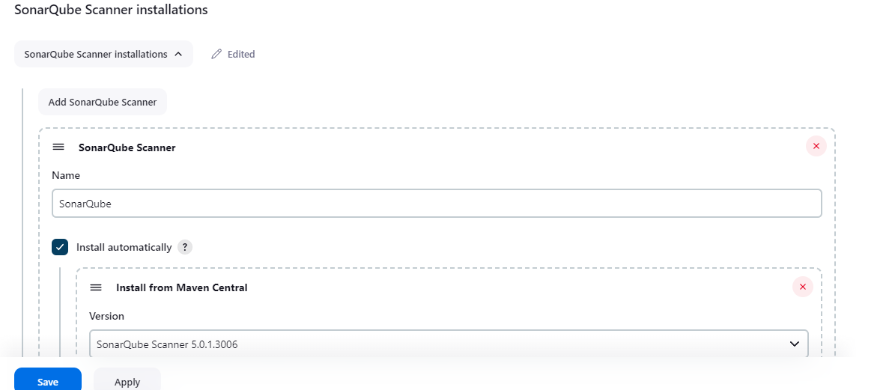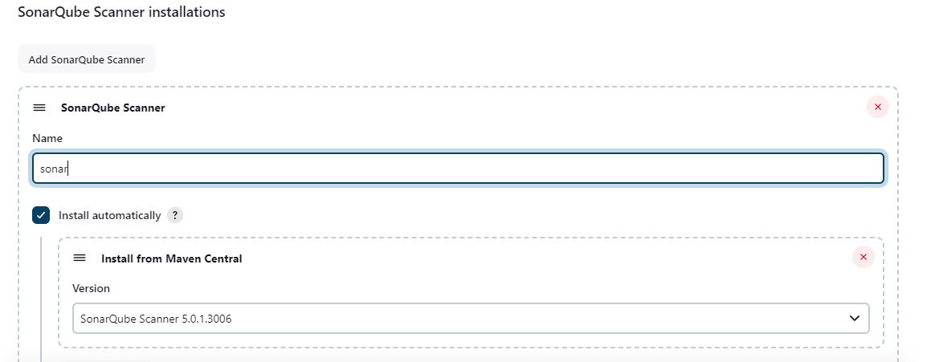

1. Configure Maven

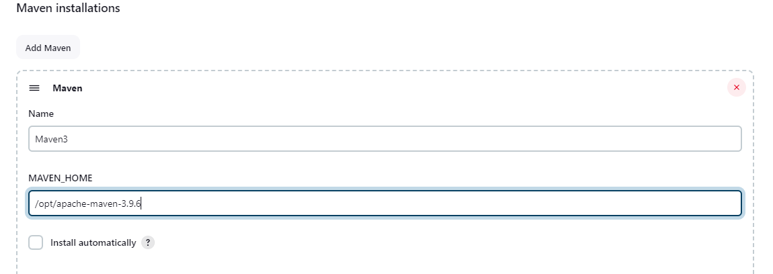

1. Configure Dependency check

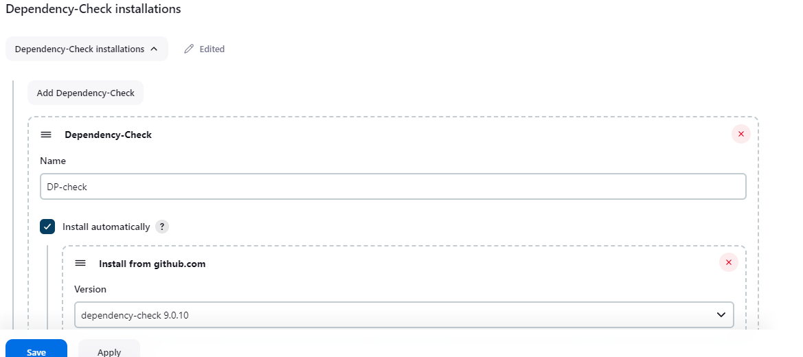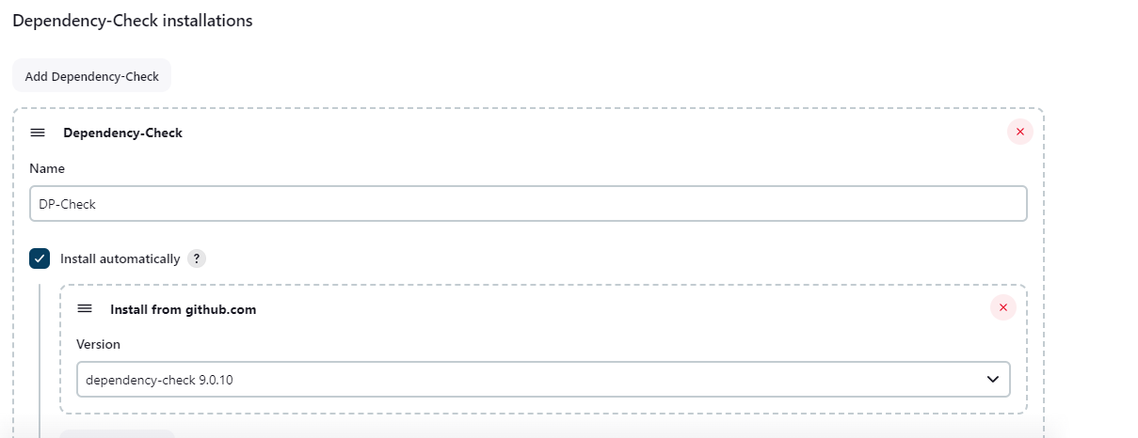

1. Configure Docker

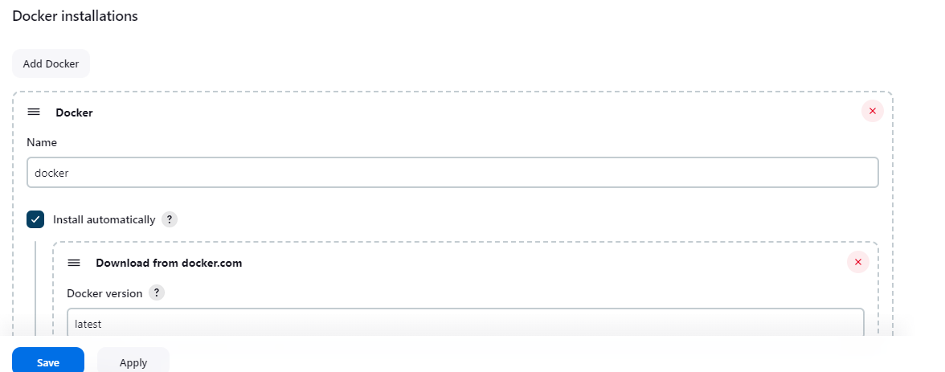

1. Click on save.
2. Goto dashboard and click on New Item
3. Enter a name, select pipeline and click on ok

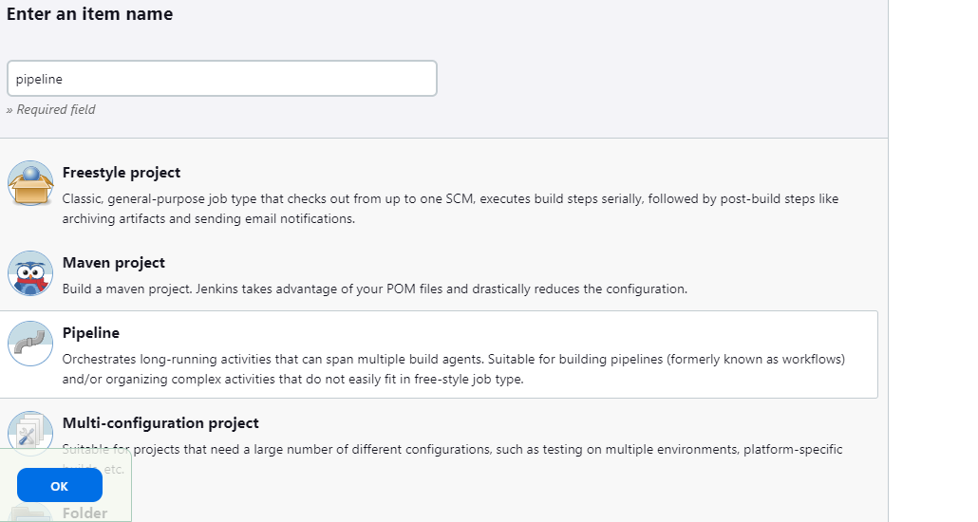

1. Goto Pipeline and configure it from github

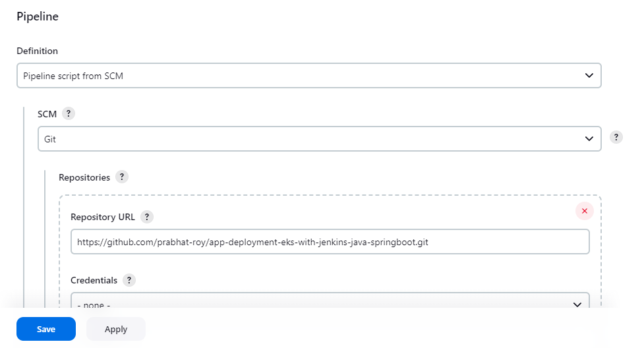

1. Change the branch from master to main and save.
2. Click on build now to run the pipeline.